
COURSE NAME: SOFTWARE ENGINEERING
ASSIGNMENT TITLE
Case Study Analysis
SOFTWARE ENGINEERING CASE STUDY REPORT
SDG 7: Solar Energy Monitoring System
Submitted By
College Name: SIMATS ENGINEERING
Department:B.Tech IT
Course Name: Software Engineering
Assignment Title: Case Study Analysis
Case Study Title: Solar Energy Monitoring System
Student Name: Ashika.B
Register Number: 192521336
Class & Section:
Faculty Name: Dr.K. Sharmili
1


Chapter No. | Topic | Page No.
1. | INTRODUCTION | 3-5
 | 1.1 Background Information
 | 1.2 Project Objectives
 | 1.3 Related SDG Goals
 | 1.4 objectives of the case of the study
2 | PROBLEM IDENTIFICATION AND ANALYSIS | 5-6
 | 2.1 Description of the Problem
 | 2.2 objectives
 | 2.3 scope | 6-7
3 | Stakeholders Analysis | 7-9
4 | Existing System Analysis | 12-13
 | 4.1 Existing Process
 | 4.2 strengths
 | 4.3 weakness
 | 4.4 Gap Analysis
5 | Proposed software solution | 9-12
 | 5.1 proposed system
 | 5.2 functional modules
 | 5.3 functional requirements
 | 5.4 non functional requirements
 | 5.5 Software Engineering Principles Applied

2


6 | System Design | 12-16
 | 6.1 use case diagram
 | 6.2 Activity Daigram
 | 6.3 Workflow Diagram
 | 6.4 System Architecture Diagram
 | 6.5 Database ER Diagram
 | 6.6 Flowchart
 | 6,7 Wireframe screens
7 | methodology / sdlc selection | 16-17
8 | implementation plan | 17-18
9 | expected outcomes | 18-19
10 | risks and limitations | 19-20
11 | future enhancements | 20
12 | . conclusion | 20-21
13 | references | 21-22
14 | appendix | 22-24

1. INTRODUCTION
1.1 Background of the Problem
The increasing demand for clean and renewable energy has led to widespread adoption of
rooftop solar photovoltaic systems in residential communities. Solar energy provides an
environmentally friendly alternative to conventional electricity generation and helps reduce
dependence on fossil fuels.
Although solar panel installations have increased significantly, many residents face
difficulties in monitoring their solar energy production, battery storage levels, electricity
3


consumption, and overall system performance. Existing monitoring methods often provide
limited information and require manual inspection of devices.
Without proper monitoring, users may not be aware of equipment failures, reduced panel
efficiency, battery degradation, or energy wastage. This can lead to reduced energy savings
and lower return on investment.
To address these challenges, a Solar Energy Monitoring System is proposed. The software
platform provides real-time monitoring, maintenance alerts, performance analytics, energy
usage tracking, and electricity savings reports through a centralized dashboard.
1.2 Importance of Solving the Problem
The proposed system helps maximize renewable energy utilization and improves energy
management efficiency.
Environmental Benefits
●​ Reduces carbon emissions.
●​ Promotes clean energy usage.
●​ Supports sustainable development.
Economic Benefits
●​ Reduces electricity bills.
●​ Improves return on investment.
●​ Lowers maintenance costs.
Technical Benefits
●​ Real-time monitoring.
●​ Automated fault detection.
●​ Historical performance tracking.
Social Benefits
●​ Increases awareness about renewable energy.
●​ Encourages sustainable lifestyles.
●​ Supports energy independence.
4


1.3 Related SDG Goals
SDG 7 – Affordable and Clean Energy
Ensures access to reliable, sustainable, and modern energy.
SDG 11 – Sustainable Cities and Communities
Promotes sustainable urban development.
SDG 13 – Climate Action
Supports reduction of greenhouse gas emissions.
1.4 Objectives of the Case Study
General Objective
To design a software-based Solar Energy Monitoring System that improves monitoring and
management of residential solar energy systems.
Specific Objectives
●​ Monitor solar energy generation.
●​ Track battery usage.
●​ Calculate electricity savings.
●​ Detect equipment faults.
●​ Generate analytical reports.
●​ Provide maintenance alerts.
●​ Improve energy efficiency.
●​ Promote renewable energy adoption.
CHAPTER 2
2. PROBLEM UNDERSTANDING
The increasing use of rooftop solar panels in residential communities supports Sustainable
Development Goal (SDG) 7 – Affordable and Clean Energy. Although households generate clean
electricity, many residents face difficulties in tracking the performance of their solar systems.
Most existing systems provide only limited information, making it hard for users to know how
5


much energy is being generated, how much battery power is available, and how much electricity
cost is being saved..
2.2 Objectives
●​ Reduce manual monitoring.
●​ Improve energy management.
●​ Increase transparency.
●​ Enhance user experience.
●​ Detect faults early.
●​ Improve maintenance planning.
●​ Generate accurate reports.
●​ Increase renewable energy efficiency.
2.3 Scope
In Scope
●​ User Registration
●​ User Login
●​ Dashboard Management
●​ Solar Energy Monitoring
●​ Battery Monitoring
●​ Electricity Savings Tracking
●​ Maintenance Alerts
●​ Performance Analytics
●​ Report Generation
●​ Admin Management
Out of Scope
●​ Solar Panel Manufacturing
6


●​ Hardware Installation
●​ Utility Billing Systems
●​ Electrical Repairs
●​ Solar Financing
3. STAKEHOLDER ANALYSIS
Stakeholder | Role | Responsibilities

Administrator | System Manager | Manage users and devices

Residents | End Users | Monitor energy generation

Energy Providers | Service Providers | Monitor solar performance

Maintenance Team Technical Support Handle repairs and maintenance
Government Agencies Regulators Renewable energy compliance
Software Developers Development Team Build and maintain system
Stakeholder Requirements
Residents
●​ Real-time monitoring
●​ Energy savings reports
●​ Battery status information
Energy Providers
●​ Centralized monitoring
●​ Performance analytics
Maintenance Team
●​ Fault alerts
●​ Maintenance scheduling
Administrators
7


●​ User management
●​ Device monitoring
CHAPTER-4
4. EXISTING SYSTEM ANALYSIS
4.1 Existing Process
Most residential solar systems use standalone inverter displays or simple mobile
applications. Users manually monitor performance and often rely on periodic inspections to
identify issues.
4.2 Strengths
●​ Easy to operate.
●​ Low software dependency.
●​ Simple installation.
4.3 Weaknesses
●​ No centralized monitoring.
●​ Limited analytics.
●​ No predictive maintenance.
●​ Poor fault detection.
●​ Lack of reporting.
4.4 Gap Analysis
Existing System Proposed System
Manual monitoring Automated monitoring
Limited information Real-time dashboard
8


Existing System Proposed System
No alerts Maintenance alerts
Basic reports Advanced analytics
Isolated devices Centralized platform
CHAPTER:5
5. PROPOSED SOFTWARE SOLUTION
5.1 Proposed System
The proposed Solar Energy Monitoring System is a cloud-based web and mobile application
that collects energy data from solar panels, batteries, and smart meters.
The platform provides:
●​ Real-time monitoring
●​ Analytics dashboard
●​ Energy savings reports
●​ Maintenance alerts
●​ Historical records
5.2 Functional Modules
Module 1 – User Registration
●​ Create account
●​ Manage profile
Module 2 – Authentication
●​ Login
●​ Password management
Module 3 – Solar Monitoring
9


●​ Real-time energy tracking
●​ Solar panel status
Module 4 – Battery Monitoring
●​ Charge level tracking
●​ Battery health monitoring
Module 5 – Analytics
●​ Energy trends
●​ Savings calculations
Module 6 – Alert Management
●​ Fault detection
●​ Maintenance notifications
Module 7 – Reporting
●​ Daily reports
●​ Monthly reports
●​ Annual reports
Module 8 – Admin Panel
●​ User management
●​ Device management
5.3 Functional Requirements
ID Requirement
FR1 Users shall register accounts.
FR2 Users shall login securely.
FR3 System shall monitor solar energy generation.
FR4 System shall track battery status.
10


ID Requirement
FR5 System shall calculate electricity savings.
FR6 System shall generate reports.
FR7 System shall send maintenance alerts.
FR8 System shall store historical data.
FR9 Administrators shall manage users.
FR10 Administrators shall manage devices.
5.4 Non-Functional Requirements
Category Requirement
Performance Response time under 3 seconds
Security Encrypted data storage
Reliability 99% uptime
Scalability Support increasing users
Maintainability Modular design
Availability 24/7 operation
Usability User-friendly interface
Portability Mobile and web support
5.5 Software Engineering Principles Applied
●​ Modularity
System divided into independent modules.
●​ Scalability
Can support large numbers of users.
●​ Reliability
Provides consistent performance.
●​ Security
Secure authentication and data encryption.
11


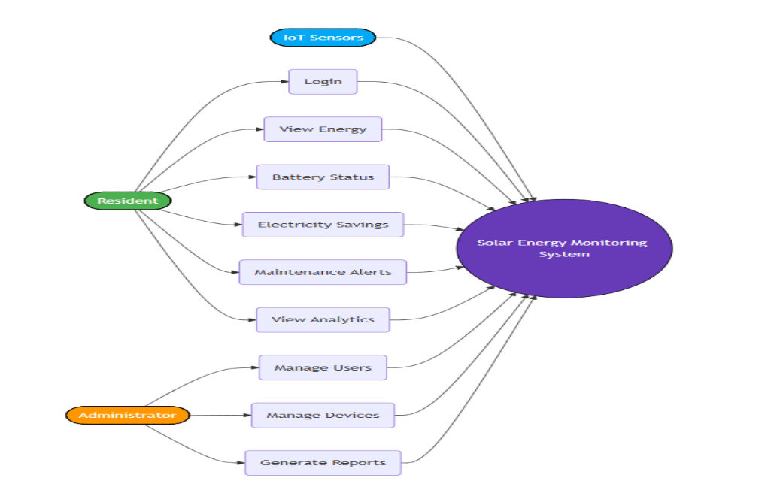


●​ Maintainability
Easy updates and bug fixes.
●​ Reusability
Reusable software components.
●​ Usability
Simple dashboard design.
●​ Flexibility
Supports future enhancements.
CHAPTER -6
CASE DIAGRAM:
ACTIVITY DIAGRAM:
12


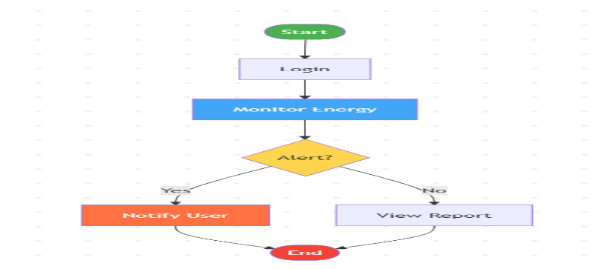
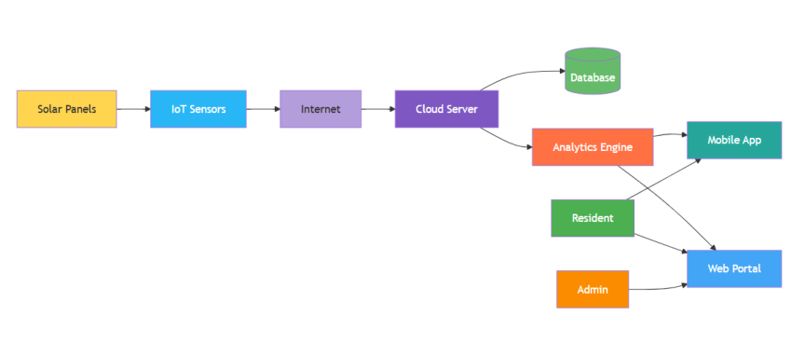

SYSTEM ARCHITECTURE:
DATABASE ER DIAGRAM:
13


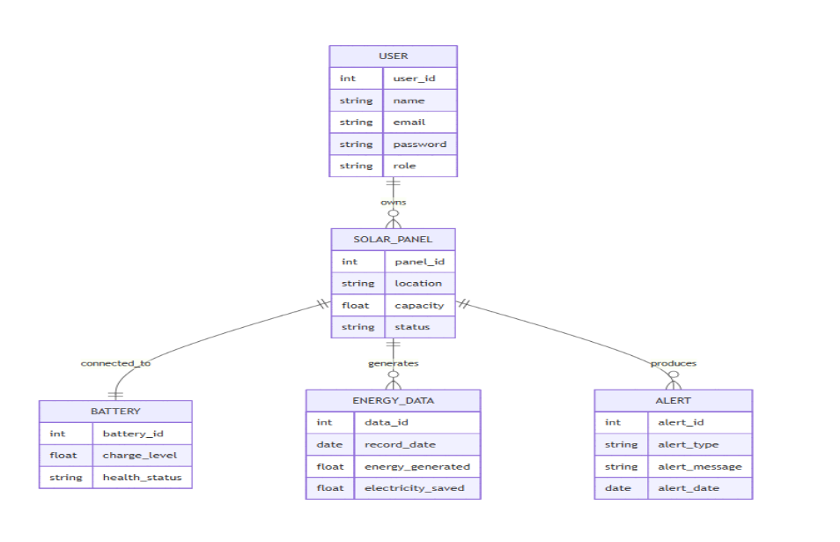
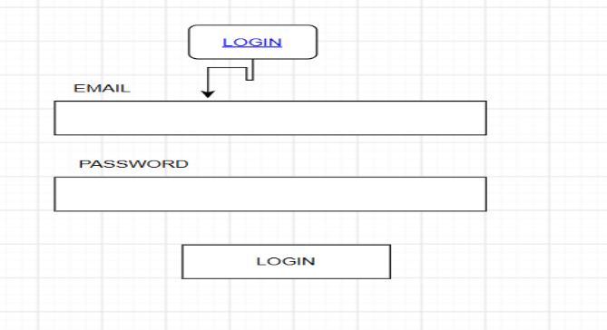


WIRE FRAME:
LOGINSCREEN
14


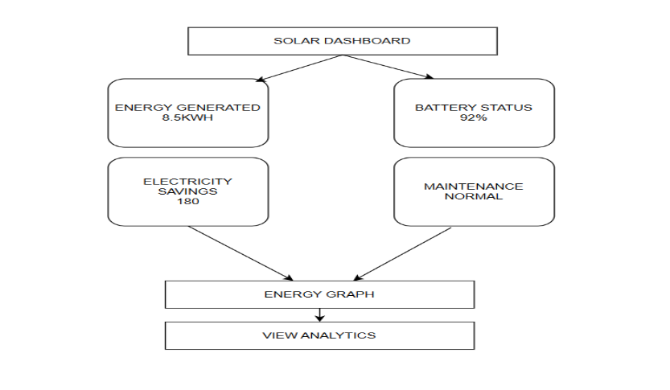

DASH BOARD:
ANALYTICS:
15


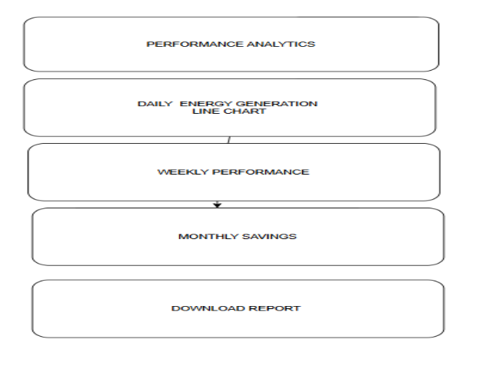
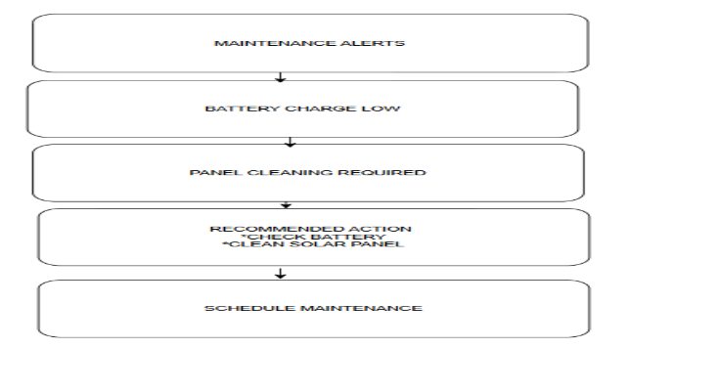


MAINTENANCE ALERT:
FLOWCHART:
16


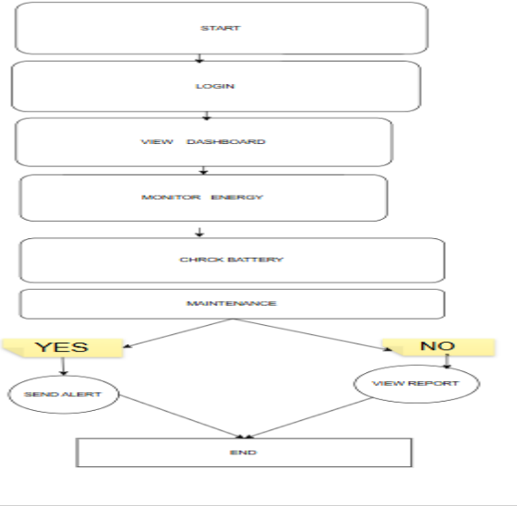

CHAPTER-7
7. METHODOLOGY / SDLC SELECTION
Selected Model: Agile Scrum
Why Agile?
●​ Continuous feedback
●​ Faster development
●​ Easy modifications
●​ Better quality
Development Stages
1.​ Requirement Gathering
2.​ Sprint Planning
3.​ Development
4.​ Testing
5.​ Deployment
17


6.​ Maintenance
CHAPTER-8
8. IMPLEMENTATION PLAN
Phase Duration
Requirement Gathering 1 Week
System Design 1 Week
Development 3 Weeks
Testing 1 Week
Deployment 1 Week
Maintenance Ongoing
CHAPTER-9
9. EXPECTED OUTCOMES
Benefits
●​ Better solar panel efficiency
●​ Improved battery utilization
●​ Reduced electricity bills
Business Impact
●​ Better service quality
●​ Reduced maintenance costs
User Benefits
●​ Real-time monitoring
●​ Savings tracking
●​ Performance analytics
Social Impact
18


●​ Sustainable energy usage
●​ Reduced carbon emissions
SDG Contribution
●​ SDG 7
●​ SDG 11
●​ SDG 13
10. RISKS AND LIMITATIONS
1. Internet Dependency
The Solar Energy Monitoring System depends on a stable internet connection to receive
real-time data from IoT sensors. If the internet connection is interrupted, users may not be
able to view live energy generation, battery status, or maintenance alerts until connectivity
is restored.
2. Data Privacy
The system stores user information, energy usage records, and device details. If proper
privacy measures are not implemented, unauthorized users may gain access to sensitive
information. Secure authentication and data encryption should be used to protect user data.
3. Security Threats
Since the system is connected to the internet, it may face cybersecurity risks such as
hacking, malware, or unauthorized access. Implementing strong passwords, secure
communication protocols, and regular security updates can reduce these threats.
4. Budget Limitations
Developing and maintaining the software requires investment in cloud storage, IoT devices,
sensors, and system maintenance. Limited financial resources may affect the addition of
advanced features and long-term support.
5. User Adoption
Some residents may not be familiar with digital monitoring systems. They may require
training or guidance to use the application effectively. A simple and user-friendly interface
can improve user adoption.
6. Technical Challenges
19


The system may experience hardware failures, sensor inaccuracies, software bugs, or server
downtime. Regular maintenance, testing, and timely updates are necessary to ensure
reliable system performance
11. FUTURE ENHANCEMENTS
1. AI Integration
Artificial Intelligence can be integrated to predict energy generation, identify faults in solar
panels, and provide intelligent maintenance recommendations based on historical
performance data.
2. Chatbot
An AI-powered chatbot can be added to answer user questions, provide troubleshooting
guidance, explain energy reports, and assist users in operating the system.
3. Mobile Application
A dedicated Android and iOS application can be developed to allow users to monitor solar
energy generation, battery status, and electricity savings anytime and anywhere.
4. Smart Notifications
The system can send instant notifications through SMS, email, or mobile push notifications
when battery levels are low, maintenance is required, or system faults are detected.
5. Weather Forecast Integration
Weather data can be integrated to estimate future solar energy production based on
sunlight intensity, cloud cover, and weather conditions.
6. Advanced Analytics Dashboard
The dashboard can include interactive charts, monthly and yearly performance
comparisons, energy consumption trends, and downloadable reports to help users make
informed decisions.
CHAPTER-12
12. CONCLUSION
20


Summary
The Solar Energy Monitoring System is designed to help residential communities monitor
rooftop solar panel performance efficiently. The system provides real-time information
about energy generation, battery status, electricity savings, maintenance alerts, and
performance analytics through an easy-to-use software platform.
Problem
Residents find it difficult to manually monitor solar energy production, battery usage, and
electricity savings. The absence of a centralized monitoring system makes it challenging to
identify faults, schedule maintenance, and analyse overall system performance.
Proposed Solution
A software-based Solar Energy Monitoring System is proposed to collect real-time data from
IoT-enabled solar panels and batteries. The system displays live energy generation, battery
health, electricity savings, maintenance alerts, and performance analytics through a web or
mobile dashboard. Administrators can also manage users, monitor devices, and generate
reports.
Benefits
●​ Provides real-time monitoring of solar energy generation.
●​ Displays battery status and electricity savings.
●​ Sends maintenance alerts to reduce equipment failures.
●​ Improves transparency and decision-making through performance analytics.
●​ Reduces manual monitoring and increases operational efficiency.
●​ Offers a user-friendly interface for residents and administrators.
Importance
The Solar Energy Monitoring System supports Sustainable Development Goal (SDG) 7 –
Affordable and Clean Energy by promoting the efficient use of renewable energy
resources. It helps residents maximise solar energy utilisation, reduce electricity costs,
improve system reliability, and encourage sustainable energy management.
13. REFERENCES
●​ International Energy Agency (IEA). (2023). Renewables 2023. Paris: IEA.
●​ International Renewable Energy Agency (IRENA). (2023). Renewable Energy
Statistics 2023. Abu Dhabi: IRENA.
21


●​ IEEE Xplore Digital Library. Research Articles on Solar Energy Monitoring Systems.
●​ SpringerLink. Smart Grid and Renewable Energy Research Publications.
●​ ACM Digital Library. Software Engineering and IoT-Based Monitoring Systems.
●​ National Renewable Energy Laboratory (NREL). Solar Energy Technologies and
Monitoring Resources.
●​ World Bank. Sustainable Energy for All (SE4ALL) Reports.
●​ Ministry of New and Renewable Energy (MNRE), Government of India. Solar Rooftop
Programme Guidelines.
●​ ISO 50001:2018. Energy Management Systems – Requirements with Guidance for Use.
●​ Sommerville, I. (2016). Software Engineering (10th Edition). Pearson Education
14. APPENDIX
Appendix A: Survey Questionnaire
A survey was conducted among residential community members to understand the need
for a Solar Energy Monitoring System. The questionnaire focused on current monitoring
methods, user challenges, and expectations from the proposed software.
Appendix B: Screenshots
The following screenshots are included in the report:
●​ Login Screen
●​ Dashboard Screen
●​ Analytics Screen
●​ Maintenance Alerts Screen
●​ Use Case Diagram
●​ Activity Diagram
●​ Workflow Diagram
●​ System Architecture Diagram
●​ Database ER Diagram
Appendix C: Additional Diagrams
The following diagrams have been prepared to explain the system design:
●​ Use Case Diagram
●​ Activity Diagram
22


●​ Workflow Diagram
●​ System Architecture Diagram
●​ Database ER Diagram
●​ Wireframe / User Interface Design
Appendix D: Sample Report
Daily Solar Energy Report
Parameter Value
Date 25-07-2026
Energy Generated 8.5 kWh
Battery Charge 92%
Electricity Saved ₹180
Panel Status Normal
Maintenance Alert No Issues
Monthly Performance Report
Parameter Value
Total Energy Generated 245.8 kWh
Total Electricity Savings ₹5,200
Average Battery Health 95%
System Efficiency 96%
Maintenance Performed 2 Times
Appendix E: Software and Tools Used
23


Software / Tool Purpose
Draw.io Workflow Diagram, Wireframe, System Architecture
Mermaid Use Case Diagram, Activity Diagram, ER Diagram
Canva User Interface (UI) Design
Figma Wireframe Design
MySQL Database Management
Visual Studio Code Software Development
Web Browser Access the Monitoring Dashboard
Appendix F: Abbreviations
Abbreviation Meaning
SDG Sustainable Development Goal
IoT Internet of Things
UI User Interface
ER Entity Relationship
DB Database
kWh Kilowatt-hour
AI Artificial Intelligence
24

